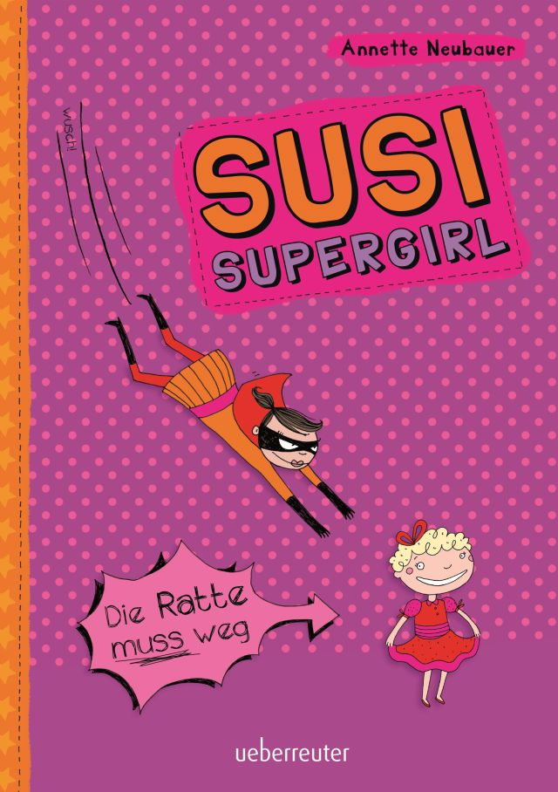

Super-duper Susi
My name’s Susi, I’m eleven years old and I’m really popular. My nickname is Supadu ‘cuz I’m super-duper at school and ‘cuz it sounds a bit like Susie. I live with my parents in a fancy apartment in a big city. In summer we always go on great trips and travel to really faraway countries.
But sadly, the summer holidays are over and today’s the first day back at school. It really sucks – but at least I’ll get to see my friends Anna and Tabea again!

Soup and Jell-O
I holler “Hi!” in the hallway, and then I throw my schoolbag into the corner and fling open the kitchen door. Mom flinches, and runs her fingers through her uncombed hair. She jumps up from her chair and hurries over to the stove. A pot of tomato soup is boiling over on the hotplate. The soup hisses and there’s a burning smell as black smoke rises.
Mom grabs a tea towel, takes off the lid and puts the pot to one side.
I cough and flap my hands about but it only makes the smoke spread more. So I wrench open the window. Then I notice an empty soup can lying in the bin. This is not a good sign.
We hardly ever eat convenience food: Mom’s always chopping up vegetables and herbs. ‘There’s only fresh food on our table!’ as she always says. She makes a lot of effort, even at lunchtime when we eat on our own without Dad – and even though she works in the mornings at a supermarket before she rushes home to cook. It makes no difference to Mom if red Jell-O with Reddi-wip tastes better than her plain old rabbit food.
Suddenly I notice a bowl on the table – of Jell-O! We only eat it on my birthday ‘cuz Mom gets grossed out by the gloopiness – but she makes it for me anyway. But today is not my birthday today. And I’m not all excited because something totally weird is going on.
I flop down on a chair as Mom dishes up the burnt soup. A short time later she sits next to me, pushes her bowl aside and holds her head in her hands. She takes a deep breath and says, “Susanne, I have to talk to you.”
Mom only calls me Susanne when she’s telling me to work harder at school, or when she’s totally mad at me because I’ve used her expensive face cream, or put on her new sandals to go shopping.
But Mom doesn’t look mad today. She looks kind of desperate. Her shoulder-length hair is hanging down in her face. Normally she’s always nicely dressed and wears make-up. But today she’s even wearing the jogging pants that she only puts on when she’s ill. Has she even been to work today? I wonder.
“Susanne,” she begins again and swallows, “as you know, me and Dad haven’t been getting on too well recently.”
I stare at her. I feel an urge to plug up my ears. They’re hurting anyway from all the yelling that’s been going on over the past few days. I look out of the window, in my head there’s a whoosh and I fly out. From up high, the world looks small, colorful and like it’s made of icing.
People are going about their business in peace and quiet, the streets are tidy and the cars are tiny. At top speed, I glide up and over them all. My hair flutters in the wind.
Then with my eagle eyes, I see a small dog trotting out onto the street! I take a nosedive, grab the dog by its fur and snatch it up in the air. Only just in time before a car…
“Susi? Are you even listening?” Mom shakes my arm. I nod although none of what she’s said has gotten through to me.
“Dad has met another woman and has left to go and live with her! Do you understand?” Mom repeats.
My body feels like the Jell-O that standing on the table in front of me.
“But he’s coming back, isn’t he?” I ask in a hoarse voice.
“I don’t know,” replies Mom “and I’m not even sure if I want him to.”
“But I want him to!” I yell and jump to my feet, knocking my chair over. “I do, d’you hear me? I do!”
I run out of the kitchen into my room and slam the door behind me. Then I flop down on my bed and stare at the wall at a photo of our last holiday: Mom, Dad and me are all wearing straw hats and laughing. I’m poking out my tongue even though I know how goofy it is.
Then I close my eyes. I want to fly back to the beach – but without Mom and Dad. But somehow, it won’t work. The weight in my belly keeps me firmly anchored to the ground.
I stand up, take the photo off the wall, and rip it up through the center, over and over again until there are only little bits of paper in my hands. I trickle them into my waste paper basket.
Then I sweep the books off my desk – crash! – and lob my teddy at the wall. When I’ve calmed down a little, I sit down at my desk and pick up my drawing pad. Drawing always comforts me.
It’s like seeing my world with fresh eyes. All of a sudden, everything’s further away and less scary.
With the pen in my hand, my fear vanishes. People and things do what I want them to do. They can’t hurt me or make me sad.
But still, I’m so pooped today that even Supergirl isn’t really in the mood to draw. When my cell phone rings, I drop my pen with a jump. It’s Anna and she’s asking if I want to come over this afternoon. Of course I do! I’d fly straight over if I could. Anything to get out of this apartment, away from here and Mom’s sad eyes.

The mega-bomb
Today we’re having my favorite food – hamburgers with French fries. Although it tastes great, I eye Mom suspiciously at lunch. Unhealthy calorie bombs are only served on special occasions in our house. My stomach lurches when I remember the recent Jell-O incident, and I wonder what mega-bomb is about to explode today. And sure enough, no sooner have I speared my last French fry with my fork than Mom takes a deep breath and says, “Susi!”
She prods around in her half-eaten hamburger bun with her fork. I breathe out, relieved. Whatever it is, she’s calling me Susi.
“Do you want to go to the movies on Saturday?”
“Sure!” I answer, finding the question a bit odd. Mom knows I always like going to the movies. I feel like giving her a hug. But I hold back and wait for any nasty surprises that might be in store.
“Would you mind if someone came with us?” she says, and there it is.
In a flash, I remember Mom talking on the phone last night with some guy. The hamburger suddenly feels stuck in my belly.
“Who?” I ask quietly, though I’ve already guessed.
“I’ve told you about Willy,” Mom says carefully, and turns a funny red color.
“He also feels like going to the movies with his kids, and I thought it would be more fun if we all went together.’
I swallow. I’d love to go to the movies with Mom and Dad, like we always did, like in the old days. Like we’ll never do again?
“I don’t want to go to the movies with some strange guy,” I hiss at Mom, jabbing my fork in the air.
“Or with any little brats who cry at the scary parts – no way!”
“He’s not ‘some strange guy, he’s a very nice person.” Mom frowns. “And his kids certainly aren’t toddlers any more.”
“But he’s a stranger to me!” I carry on furiously.
“Then you can just stay here,” replies Mom, with deliberate calm. At the same time, she nervously scrunches up a napkin and starts ripping it into little pieces with her fingers.
“I don’t believe it!” I burst out. “You’d leave me all on my own on Saturday night?”
“It’s up to you,” Mom replies. She has a really calm expression but she’s not fooling me. I know her too well. I can hear how high and tight her voice sounds.
“If you do decide to come, I’d be really happy. But if you don’t, you can stay at home or spend Saturday with Grandpa. Just think it over.”
The world doesn’t make sense to me any more. Does Mom really want to spend her weekend with a strange guy and his kids more than with me, her one and only daughter? I look her in the eyes and know: Yes, she does. Traitor!
“How old are his kids anyway?” I ask, trying to patch things up.
I won’t get anywhere with her otherwise. And it can’t harm to have more information about the enemy and his pack.
“Patricia is eight and Hannes is almost fifteen,” Mom explains with relief, even though I’m faking interest as I picture how to scare a little girl to death in the movie theater. A whole bunch of things instantly spring to mind. Unfortunately, it’s going to be a lot more difficult with a 15-year-old, pimply teen boy.
“Ok then. If you want,” I give in, and clear the dishes from the table, “then we’ll spend Saturday together, all five of us.”
Mama hugs me and sighs, “Thanks, Susi!”
As I fill the dishwasher, I add quietly, “Just like a real extended family.” But as I say this, I act like I’m barfing onto the dirty dishes. But Mom pretends she hasn’t seen me and just wipes the table.

The next few days drag slowly. Anna and Tabea are talking to me again but they’re not being particularly nice. When I ask if they want to come over, they’re always really busy.
Dad calls once to say that he’s thinking of me and that he’ll call again. Why doesn’t he just come over if he wants to see me? I wonder if Julia refuses to let him see me? I take out my cell phone a few times, then put it away again. Dad left, so he should be the one to call me.

On Saturday, Mom is all excited and paints her toenails the same tacky red as her fingernails.
“Oh, shoot,” she says as she stands in front of her wardrobe. “My purple dress doesn’t go with my nail polish.
“The white dress suits you better anyhow,” I reply because I’ve totally forgotten that she’s getting dressed up for this stupid guy.
“With the low-cut back?” she asks and pouts pensively.
Then it occurs to me again that it’s Dad’s favorite dress. Or was Dad’s favorite dress? Will Mom never get dressed up for Dad again?
Silently, I watch as Mom slips on the white dress and turns back and forth in front of the mirror. She looks great! Even the dullest guy would have to see that. But this thought doesn’t cheer me up. I hope Willy doesn’t lay a finger on Mom.
“You’re not even dressed,” says Mom and looks at my old jogging pants, shaking her head. Then she grabs me by the shoulders and steers me out of her bedroom.
“Hurry up! Put on something nice. The pink blouse looks great on you.”
The pink blouse with the ruffles was a present from my aunt. It’s the most hideous garment on earth, and I only wear it at Christmas. And only because I love my aunt so much. I go into my room and open my wardrobe door. Without thinking much, I take out my ripped jeans, my oldest sneakers and my Supergirl T-shirt. The T-shirt is really baggy on me; actually it’s a men’s Superman T-Shirt and three sizes too big. I look at myself in the mirror and I’m satisfied. I’m about as bulky as a trash can. My eyes catch sight of the scissors on my desk. Then I look back into the mirror. I shake out my long black hair that’s sticking up all over the place and poke out my tongue.
I grab a few strands of hair in one hand and pick up the scissors with the other. I start cutting. Snip, snip, snip! Thick clumps of hair fall to the floor. I snip my bangs and they getting more and more crooked. Then the doorbell rings.

The freaky trio turns up
I stand behind my bedroom door and press my ear against it. I hold my breath to hear better. Mom’s footsteps clack down the hallway. “Oh, how wonderful that you’re all here!” she says in her phony voice.
I don’t like it when she talks like that and waves her hands around at the same time. Then a boy’s voice mutters “Hullo,” and a reedy voice squeaks “Good afternoon.” Sounds like a perfect goody two-shoes.
Before Mom can drag me out of my room, I open the door myself. Mom stares at me, flinches, and staggers backwards. My little surprise worked! I tousle my unusually short hair – and then it’s my turn be surprised. Willy is worse than I’d expected. He’s as thin as a whippet, gaunt and scraggy. I bet you can count each one of his ribs when he’s naked. A bag of bones.
He has horn-rimmed glasses on the tip of his nose. What’s left of his hair is parted neatly in the center, combed and trimmed. He’s wearing a checked shirt, way-too-short pants and his bare feet stick out of exercise sandals.
Hannes, the son, must take after his mother – he’s the total opposite. His belly hangs over the belt of his baggy jeans. He has pimples and shoulder-length hair. Of course, he pretends not to notice me, and stares down at his worn-out sneakers. His kid sister, Patricia, looks cute in her little red dress and with blond curls. But she’s way too petite and skinny for an eight-year-old. What a freaky trio they make standing in our hallway!
At last, the creep takes a step towards me, and reaches out a thin, weedy hand. “Hello, Susanne, just call me Willy.” I cringe.
“Huh,” I say by way of greeting, and thrust my hands into my pockets. Mom goes bright red. She’s probably really mad at me. Like I could care less. I’m furious with her!
Embarrassed, Willy puts his hand back in his pocket and gives me a dumb grin. “Well, let’s go then! The film starts soon.”
Before we’ve even get in the car, Mom starts prattling away.
Willie hangs on every word coming from her cherry-red lips as I trot behind them with Hannes and Patricia. Hannes doesn’t say anything, but he snorts next to me as if he’s running a marathon. I guess it’s because he’s so fat.
I suddenly notice a tugging at my T-shirt.
“My mommy has dark hair too,” whispers Patricia and looks up at me, “but it’s not as weird as yours.”
I quickly shake off the little rat. OK, her comments aren’t totally off the mark. But all the same, she’s not allowed to say things like that.
“You’re kind of puny for your age,” I answer. I quickly poke my tongue out at her and pull a face. Patricia flinches but she doesn’t say anything.
Willie opens the car door and we squeeze onto the rear seat of his old, rusty station wagon. So he doesn’t even have any cash! Patricia sits in the middle. That’s fine by me. That way I don’t touch Acne Boy.
As I feel Patricia’s teeny body next to me, I remember what she said. Where is her mom anyway? But before I have time to ask her, Mom turns round to us.
“Are you guys looking forward to the cartoon?” she trills.
What a dumb question! She knows I love cartoons. What I hate in the movies are popcorn-crunchers and straw-slurpers sitting next to me. Crunch! Chomp, slurp burp, gulp, guzzle!
I hope that Patricia and Hannes hate popcorn and coke. Probably not!
“Do you like cartoons?” asks Mom again.
Hannes answers with a stubborn silence, which kind of makes me like him more. Patricia warbles, “Yeah, the animals in the new film are s-o-o-o-o c-u-u-u-ute! I’ve seen the trailer on TV lots of times. The part I like best is when the guinea pig rides on the donkey. I used to go to the zoo with my mom and look at the guinea pigs and donkeys. But I think the ponies are funnier.”
“Susi likes going to the zoo too,” says Mom in her sweet-talk voice.
I roll my eyes.
Mom and Patricia babble on until we reach the movie theater. We drive around in circles because Willy the whippet doesn’t want to fork out for parking money. When we finally reach a free parking lot, it’s late and we have to trudge halfway back through town to the movie theater.
When we finally get there, we rush to the box office.
“I want popcorn!” squeaks Patricia as Willy is paying for the tickets. “Oh, please! Mommy always let us have popcorn!”
Willy strolls over to the popcorn counter and returns with a huge bucket brimming with white din-makers.
“For all three of you!” he says and smiles as if he’s doing me a major favor. Patricia beams at him. Hannes pulls up one side of his mouth and I groan loudly. Bucket in hand, Willy takes the lead. In the theater, it’s already dark and a woman with long, glossy hair is flickering across the enormous screen.
I run my fingers through the new stubble on my head. Have I been horrible today?
Willy walks down the steps with the bucket to the second row. We squeeze past some people already sitting in the audience who pull in their knees.
Willy sits down first. Next to him sits Mom, then me. On my left sits the little rat, who’s holding tightly on to her brother’s hand. When we’re all finally seated, Willy gets up again to pass Patricia the popcorn, which she puts on her lap.
Then the movie starts. It’s great! After a few minutes, I’ve forgotten everything – the fact that Dad has left, Mom has caught herself a whippet, and that a pimply teenager is sitting next to me. Then the little rat starts rustling away. Crunch, scrabble! Guzzle, munch, burp!
The movie is ruined but my mind starts rolling. I turn into Susi Supergirl and imagine grabbing Patricia. I fly up high and out of the cinema, taking her up to the roof and then, whoosh!…

